FAQ

1 . What if you want to make changes and how the workflow will be ?
make changes → git commit → git push → GitHub Actions auto-builds → deploys to Azure

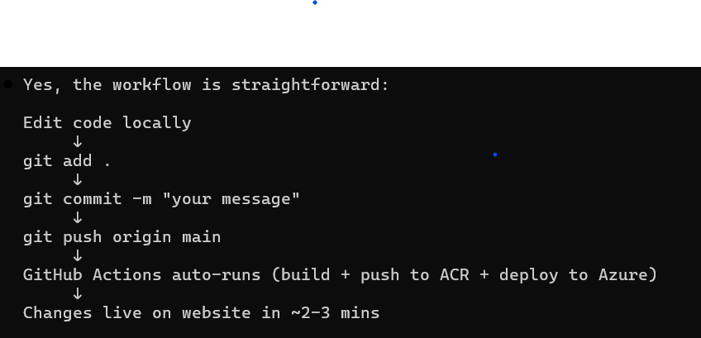

2. Secrets on Github ?
